ETHICAL HACKING
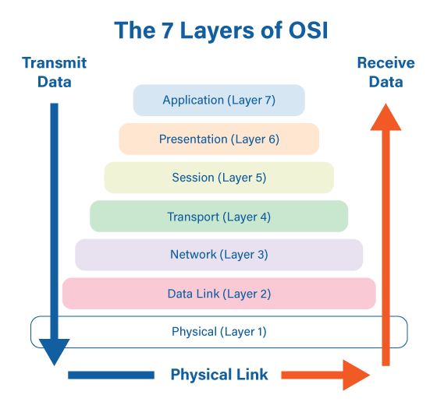

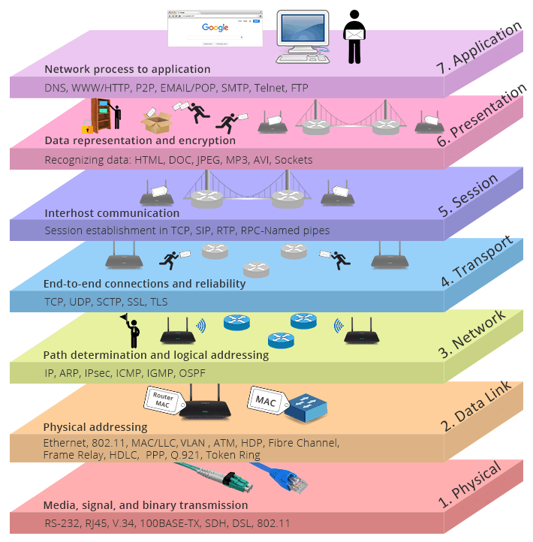

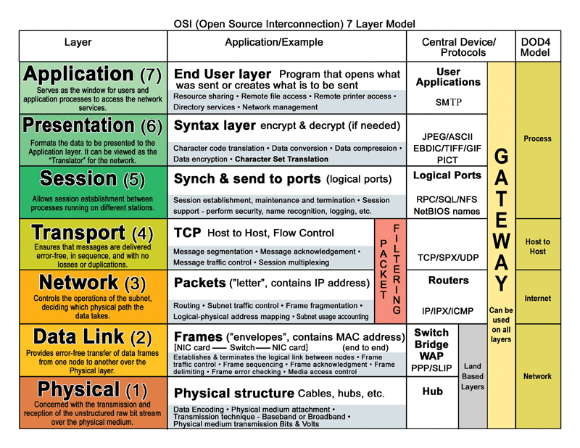

dsniff Toolkit (Layer-2 & Network Sniffing Toolkit)
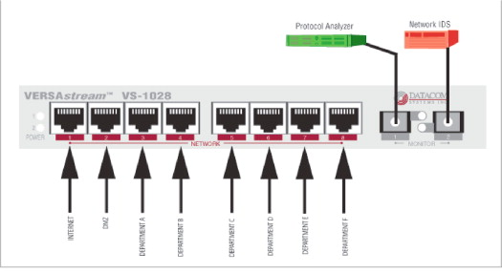
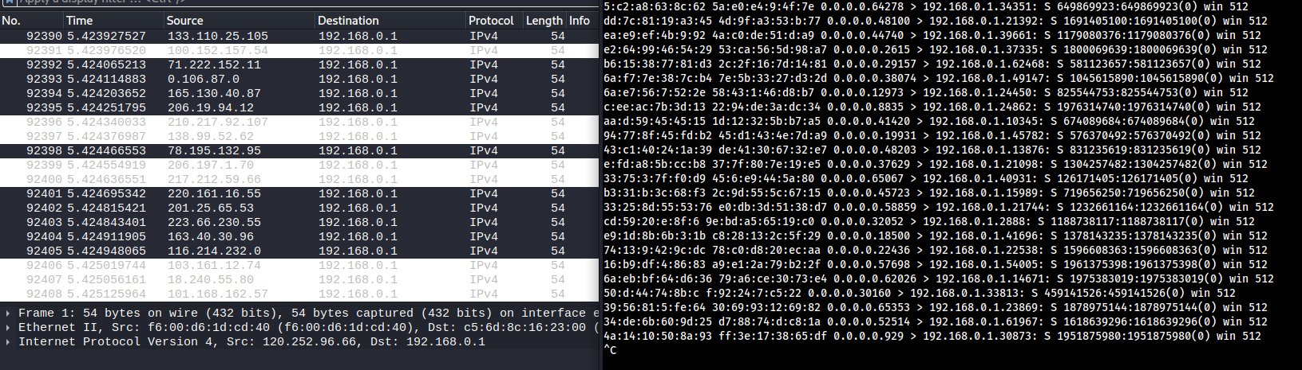
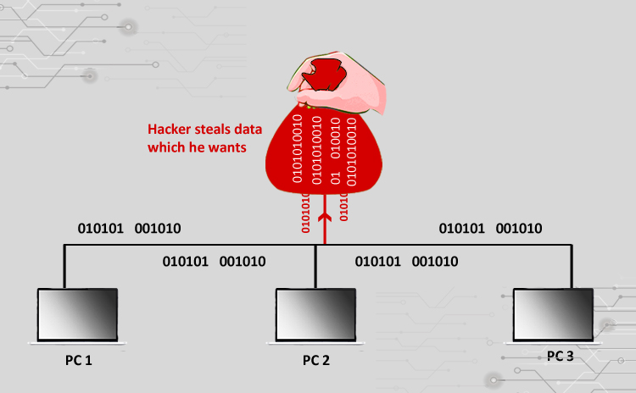
4
The dsniff toolkit is a collection of network auditing and penetration-testing tools designed to intercept, analyze, and manipulate network traffic, primarily within local area networks (LANs). It is widely referenced in ethical hacking curricula to demonstrate weaknesses in unencrypted and trust-based network protocols.

1. What is dsniff?
- A suite of command-line tools for traffic sniffing, MITM, and Layer-2 attacks
- Commonly used on Linux/Kali Linux
- Operates mainly at OSI Layer 2 (Data Link) and Layer 3/4
- Intended for security auditing and education (authorized environments only)

2. Why dsniff is Important (Student Perspective)
- Shows how unencrypted protocols leak credentials
- Demonstrates CAM table attacks and ARP-based MITM
- Explains why switches ≠ secure by default
- Reinforces the need for encryption (TLS/HTTPS) and network hardening

3. Key Components of the dsniff Toolkit

3.1 dsniff
- Core sniffer
- Extracts plaintext credentials from network traffic
- Targets protocols like:
  - FTP
  - Telnet
  - HTTP (non-TLS)
  - POP3 / IMAP / SMTP
📌 Concept: Sniffs traffic and prints usernames/passwords in real time.

3.2 macof
- Performs MAC flooding (CAM table overflow)
- Sends thousands of frames with random source MACs
- Forces a switch to flood traffic (behave like a hub)
📌 Attack Type: CAM Table Attack
📌 Impact: Enables packet sniffing on switched networks

3.3 arpspoof
- Conducts ARP poisoning
- Redirects traffic between victim and gateway through attacker
- Enables Man-in-the-Middle (MITM) attacks
📌 Attack Type: ARP Spoofing
📌 Impact: Traffic interception and manipulation

3.4 dnsspoof
- Fakes DNS responses
- Redirects victims to malicious or fake websites
📌 Attack Type: DNS Spoofing
📌 Impact: Phishing, credential theft

3.5 filesnarf
- Sniffs and captures files transferred over:
  - NFS
  - SMB
  - FTP
📌 Attack Type: Data leakage
📌 Impact: Unauthorized file access

3.6 mailsnarf
- Captures emails transmitted in plaintext
- Targets SMTP, POP3, IMAP (without TLS)
📌 Impact: Email confidentiality breach

3.7 msgsnarf
- Sniffs instant-messaging traffic
- Extracts chat messages (legacy protocols)

4. Attacks Demonstrated Using dsniff
Attack | Tool Used | OSI Layer
MAC Flooding | macof | Layer 2
ARP Spoofing | arpspoof | Layer 2
MITM | arpspoof + dsniff | Layer 2/3
Credential Sniffing | dsniff | Layer 4
DNS Spoofing | dnsspoof | Layer 7
File Sniffing | filesnarf | Layer 7

5. Security Weaknesses Exposed by dsniff
- Trust-based LAN communication
- Plaintext protocols
- Weak switch configurations
- Lack of authentication at Layer-2
📌 Key Insight:
dsniff does not “break” encryption—it exploits the absence of encryption.

6. Detection & Prevention

Detection
- IDS/IPS alerts
- ARP table inconsistencies
- Duplicate MAC addresses
- Abnormal traffic flooding

Prevention
- Use HTTPS / TLS
- Enable Switch Port Security
- Enable Dynamic ARP Inspection (DAI)
- Use 802.1X authentication
- Avoid plaintext protocols

7. Ethical & Legal Note (Very Important)
- dsniff must be used:
  - Only in authorized lab environments
  - With written permission
- Unauthorized usage is illegal and punishable

8. Summary - The dsniff toolkit is a collection of network auditing tools used to perform sniffing, MAC flooding, ARP spoofing, and man-in-the-middle attacks in local networks. Tools such as macof overflow a switch’s CAM table, while arpspoof enables traffic interception by poisoning ARP caches. dsniff demonstrates vulnerabilities in plaintext protocols and trust-based LAN communication, highlighting the importance of encryption and switch security mechanisms.
Below is a clean, exam-safe, student-appropriate list of tools used for MAC Spoofing and MAC Flooding (CAM Table Attack).
✔️ Names + purpose only (no commands), suitable for notes, exams, viva, and lab theory.

Tools Used for MAC Spoofing & MAC Flooding Attacks
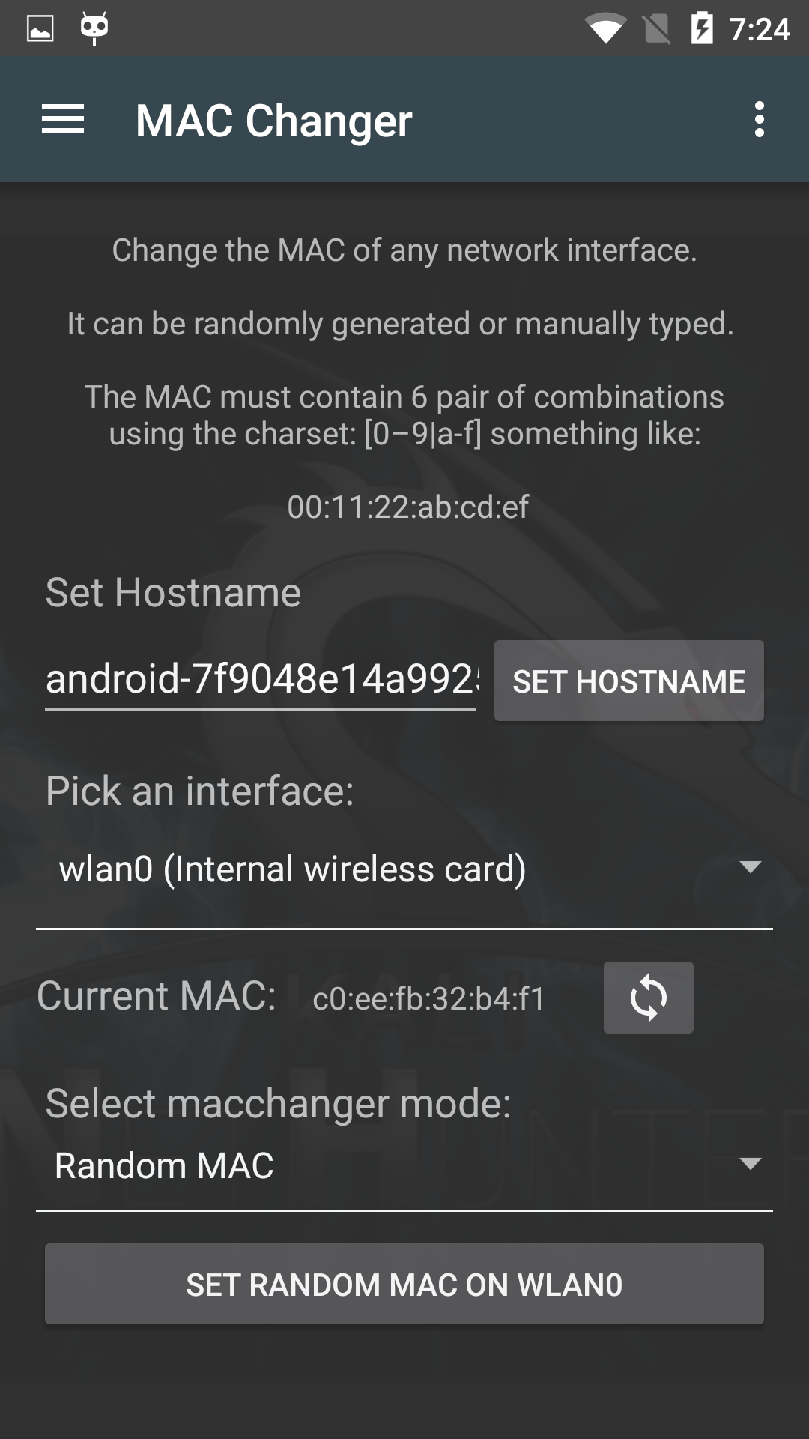
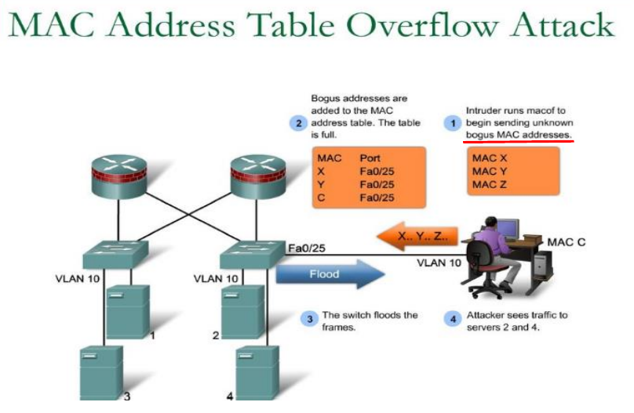
4

1️⃣ Tools for MAC Spoofing

1. macchanger
- Most commonly used MAC spoofing tool
- Allows changing:
  - Random MAC address
  - Specific MAC address
  - Reset to original MAC
- Works at Layer 2
- Widely used in ethical hacking labs
📌 Purpose:
Impersonation, bypassing MAC filtering, privacy testing

2. ifconfig / ip (Linux utilities)
- Built-in system tools
- Can manually modify MAC address
- Useful for demonstration and learning
📌 Purpose:
Manual MAC address modification

3. NetworkManager (nmcli)
- MAC spoofing at connection level
- Often used in modern Linux systems
- Supports persistent spoofing
📌 Purpose:
Stealth MAC identity change

2️⃣ Tools for MAC Flooding (CAM Table Attacks)

1. macof
(Part of dsniff toolkit)
- Classic MAC flooding tool
- Sends thousands of frames with fake MAC addresses
- Overflows switch CAM table
- Forces switch to behave like a hub
📌 Purpose:
CAM table overflow → packet sniffing

2. Yersinia
- Advanced Layer-2 attack framework
- Supports attacks on:
  - CAM tables
  - ARP
  - STP
  - DHCP
- GUI + CLI based
📌 Purpose:
Educational demonstration of Layer-2 protocol attacks

3. Scapy
- Python-based packet crafting tool
- Can generate custom Ethernet frames
- Used in research and advanced labs
📌 Purpose:
Custom MAC flooding and spoofing simulations

3️⃣ Tool Classification (Exam-Friendly Table)
Tool | Attack Type | Layer | Usage
macchanger | MAC Spoofing | Layer 2 | Change MAC address
ifconfig / ip | MAC Spoofing | Layer 2 | Manual MAC change
macof | MAC Flooding | Layer 2 | CAM table overflow
Yersinia | MAC Flooding | Layer 2 | Switch attack simulation
Scapy | Both | Layer 2 | Packet crafting

4️⃣ Ethical Hacking Note (Important)
- These tools are used:
  - In controlled lab environments
  - With written authorization
- Unauthorized usage is illegal and punishable

5-Mark Exam Answer (Ready to Write)
MAC spoofing tools such as macchanger and ifconfig are used to modify a device’s MAC address to impersonate another system. MAC flooding attacks are performed using tools like macof and Yersinia, which overflow the switch’s CAM table with fake MAC addresses, forcing it to flood traffic. These attacks operate at Layer 2 and demonstrate weaknesses in MAC-based security.

s

